

Students Name:………………………………………

SPECIALIST MATHEMATICS

TRIAL EXAMINATION 1

2012

Reading Time: 15 minutes
Writing time: 1 hour

Instructions to students
This exam consists of 11 questions.
All questions should be answered.
There is a total of 40 marks available.
The marks allocated to each of the 11 questions are indicated throughout.
Students may not bring any notes or calculators into the exam.
Where more than one mark is allocated to a question, appropriate working must be shown.
Where an exact answer is required to a question, a decimal approximation will not be accepted.
Unless otherwise indicated, diagrams in this exam are not drawn to scale.
The acceleration due to gravity should be taken to have magnitude 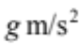where 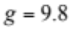
Formula sheets can be found on pages 12-14 of this exam.

This paper has been prepared independently of the Victorian Curriculum and Assessment Authority to provide additional exam preparation for students. Although references have been reproduced with permission of the Victorian Curriculum and Assessment Authority the publication is in no way connected with or endorsed by the Victorian Curriculum and Assessment Authority.

© THE HEFFERNAN GROUP 2012
This Trial Exam is licensed on a non transferable basis to the purchasing school. It may be copied by the school which has purchased it. This license does not permit distribution or copying of this Trial Exam by any other party.
Question 1

For the relation 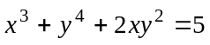 find 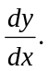

2 marks

Question 2

A windchime with a mass of 1kg is suspended from the roof of a verandah by a light rope.
A wind blowing from the right exerts a horizontal force of magnitude 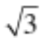 g newtons on the wind chime as shown below.
The tension in the rope is T newtons.

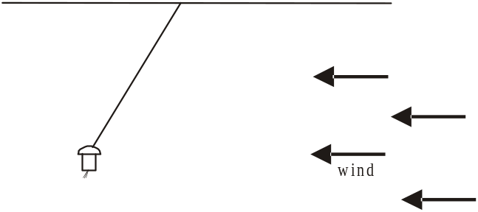

- Label all the forces acting on the windchime on the diagram above.

1 mark

- Find the tension in the rope expressed in newtons.

2 marks
Question 3

Resolve the vector 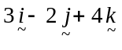 into two vector components, one parallel to the vector 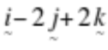 and the other perpendicular to it.

3 marks

Question 4

The complex number 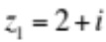 is a solution to the equation 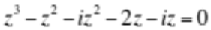.

- Find the other solutions.

2 marks

- On the Argand diagram below, plot the complex numbers

- 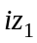

ii. 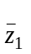

iii. 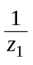

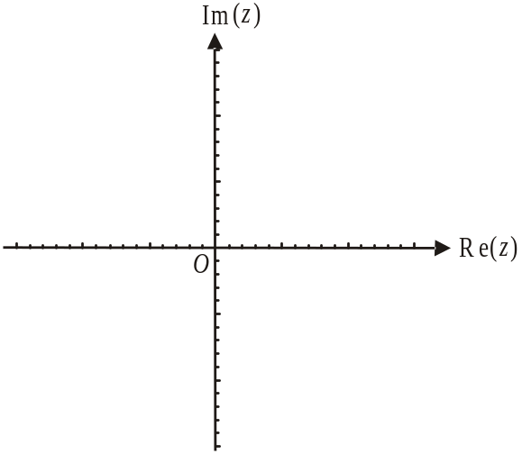

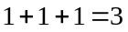 marks

Question 5

The position vector of a moving particle is given by

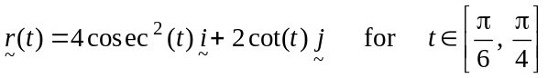.

- Find the Cartesian equation of the path of the particle.

2 marks

- Find the domain of the relation found in part a..

2 marks

Question 6

Evaluate 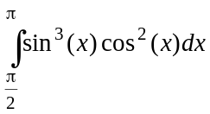.

3 marks

Question 7

For the differential equation

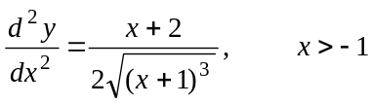,

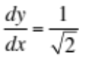when 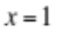and 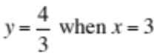.

If 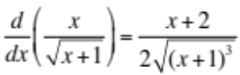, solve this differential equation.

3 marks

Question 8

Find the area enclosed by the curve with equation 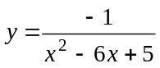, the x-axis and the lines 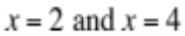.

4 marks

Question 9

Let 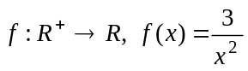.
The region enclosed by the graph of 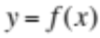, the y-axis and the lines 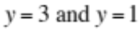, is rotated about the y-axis.

Find the volume of the solid of revolution that is formed.

3 marks

Question 10

Let 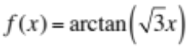 where the function f has a maximal domain.

- On the set of axes below, sketch the graph of . Indicate clearly on your graph any axes intercepts and the equation of any asymptotes.

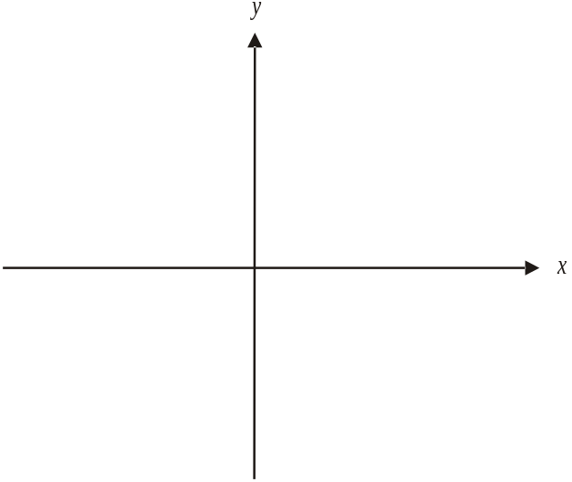

2 marks

- Find the equation of the tangent to the graph of at the point where 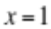.

3 marks

Question 11

- Using Euler’s method, find 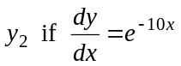, given that 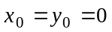 and the step size is 0.1.

2 marks

- The actual value of 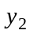 can be found by solving the differential equation in part a. The difference between the actual value and the estimated value of can be expressed in the form 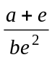 where a and b are integers.
Find the values of a and b.

3 marks

Specialist Mathematics Formulas

Mensuration
area of a trapezium: 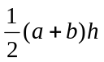
curved surface area of a cylinder: 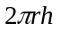
volume of a cylinder: 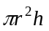
volume of a cone: 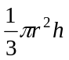
volume of a pyramid: 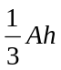
volume of a sphere: 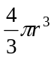
area of a triangle: 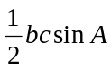
sine rule: 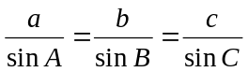
cosine rule: 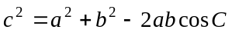

Coordinate geometry
ellipse: 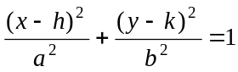 hyperbola: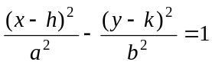

Circular (trigonometric) functions
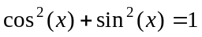
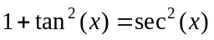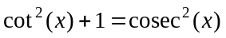
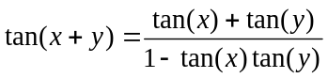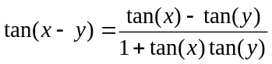
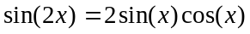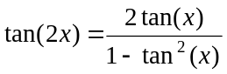
function | 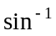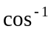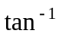
domain  range | 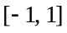  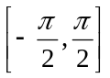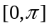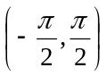

Algebra (Complex numbers)
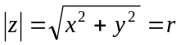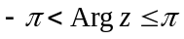
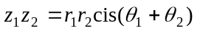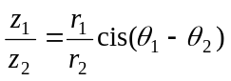
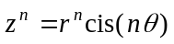 (de Moivre’s theorem)
Reproduced with permission of the Victorian Curriculum and Assessment Authority, Victoria, Australia.
This formula sheet has been copied in 2012 from the VCAA website www.vcaa.vic.edu.au
The VCAA publish an exam issue supplement to the VCAA bulletin.
Calculus

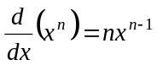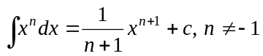
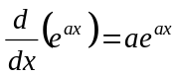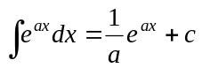
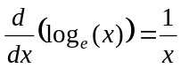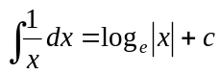
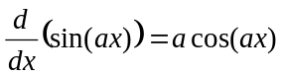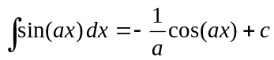
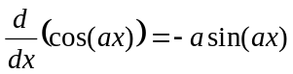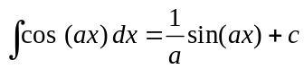
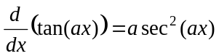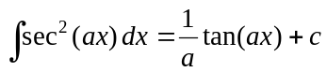
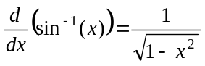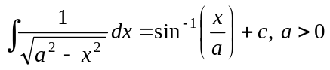
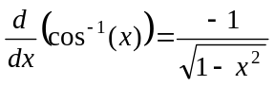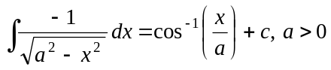
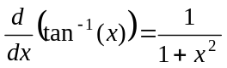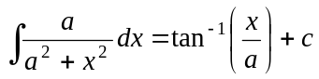

product rule: 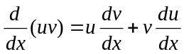
quotient rule: 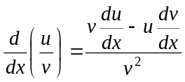
chain rule: 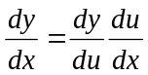
Euler’s method: 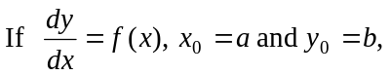
acceleration: 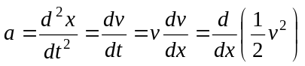
constant (uniform) acceleration: 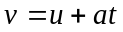 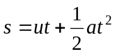 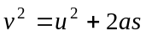 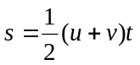

Reproduced with permission of the Victorian Curriculum and Assessment Authority, Victoria, Australia.
This formula sheet has been copied in 2012 from the VCAA website www.vcaa.vic.edu.au
The VCAA publish an exam issue supplement to the VCAA bulletin.

Vectors in two and three dimensions

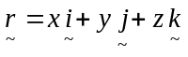
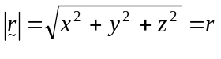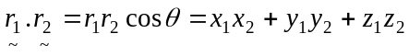
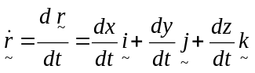

Mechanics

momentum: 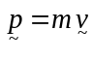
equation of motion: 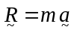
friction: 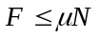

Reproduced with permission of the Victorian Curriculum and Assessment Authority, Victoria, Australia.
This formula sheet has been copied in 2012 from the VCAA website www.vcaa.vic.edu.au
The VCAA publish an exam issue supplement to the VCAA bulletin.

